# Snapshot

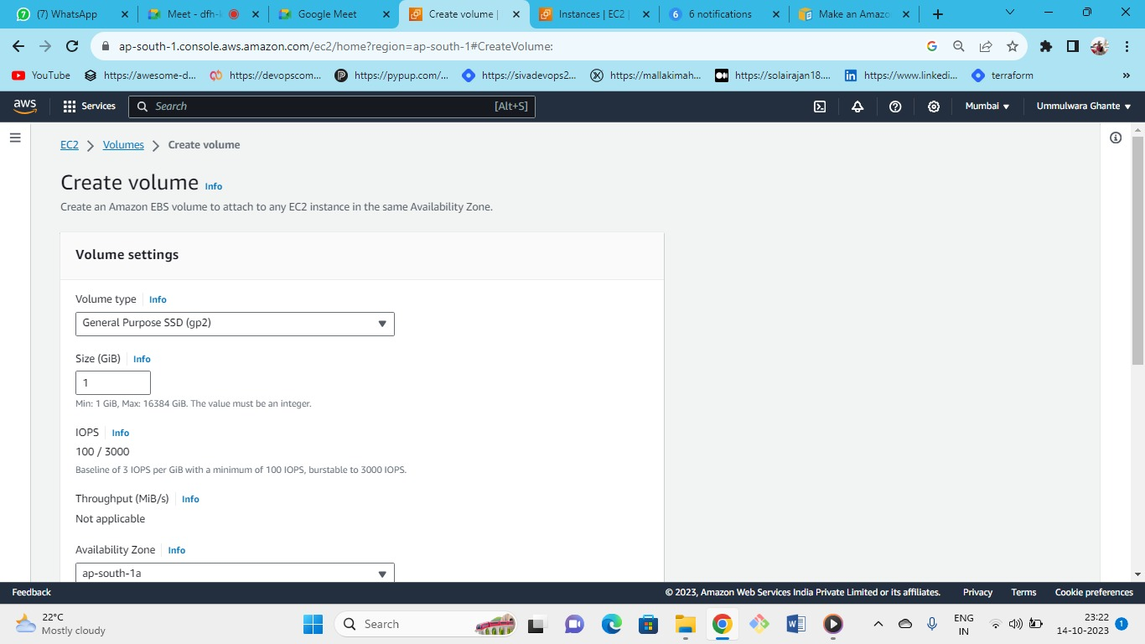

Create one extra volume for the windows server in AZ-1A.

**Movement Of snapshots**

1. **Same region but different AZ – (volume 1 in Mumbai -1A)🡪 want same volume in (volume 1 in Mumbai 1B)**

**Use Case : Cross AZ replacement when you need to attach 1A volume to 1B instance**

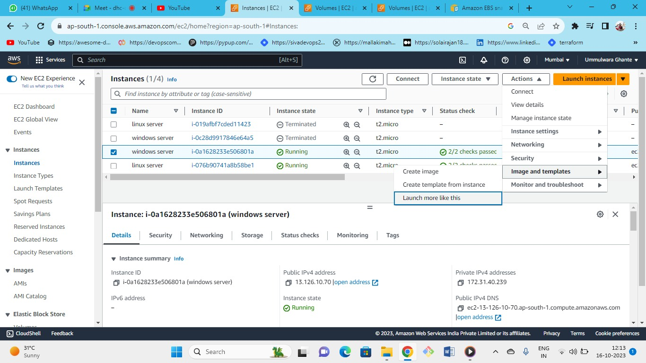

We are launching windows server 1B similar to our ec2 instance (windows server 1A) (like AZ,VPC, SG etc) in AZ-B

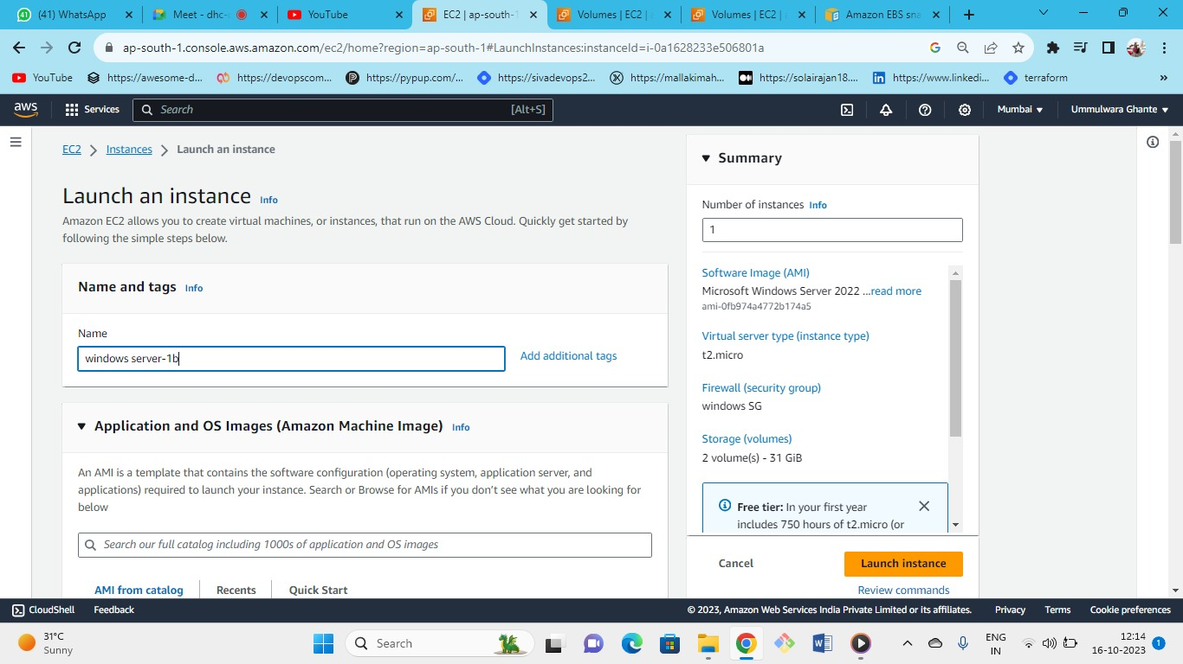

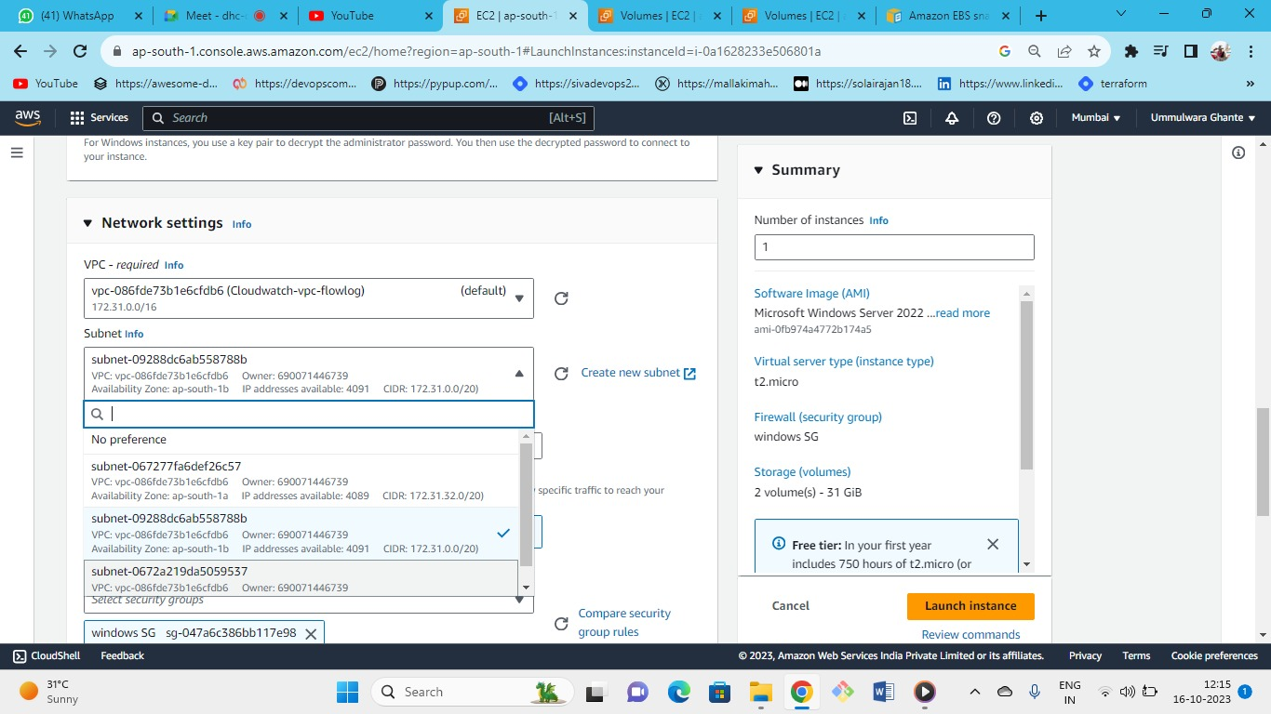

Select subnet as 1B

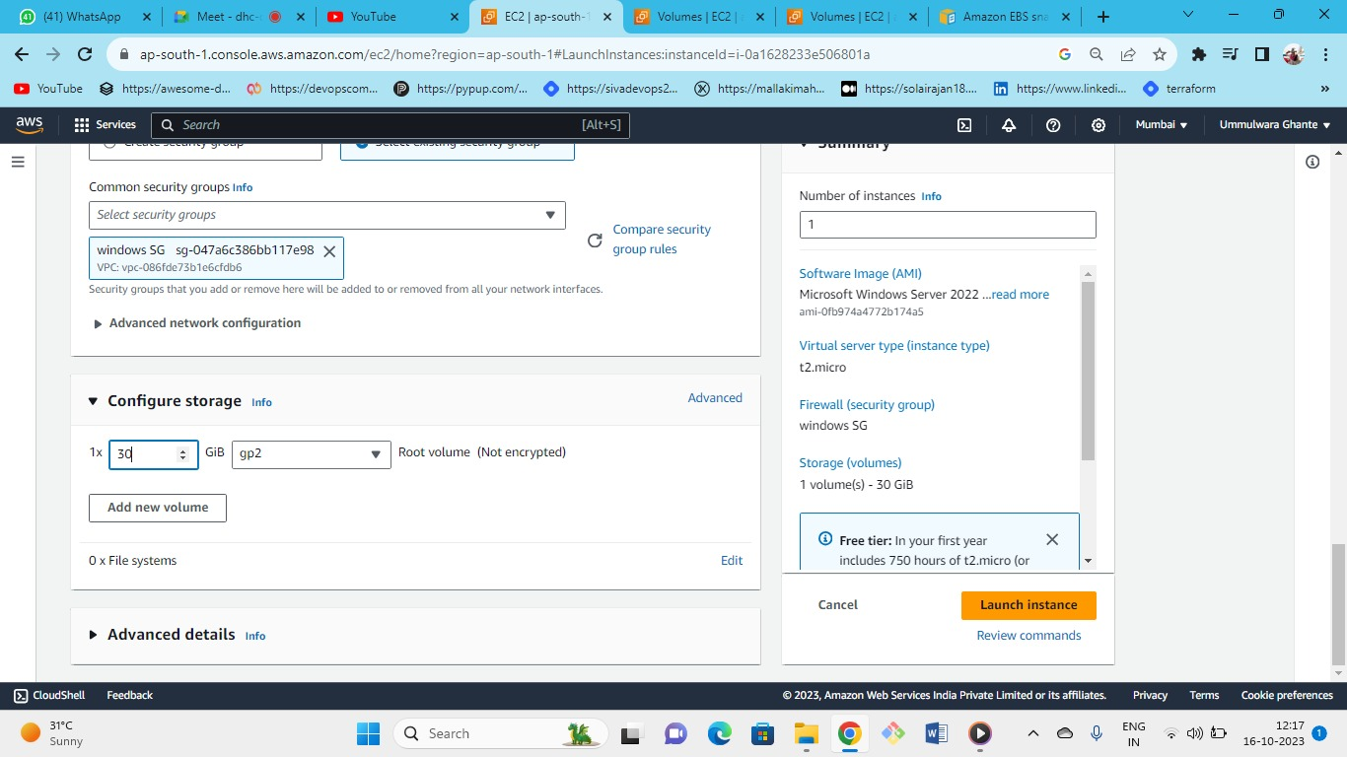

Successfully launched windows server 1B

Now Connect windows server-1a by RDP

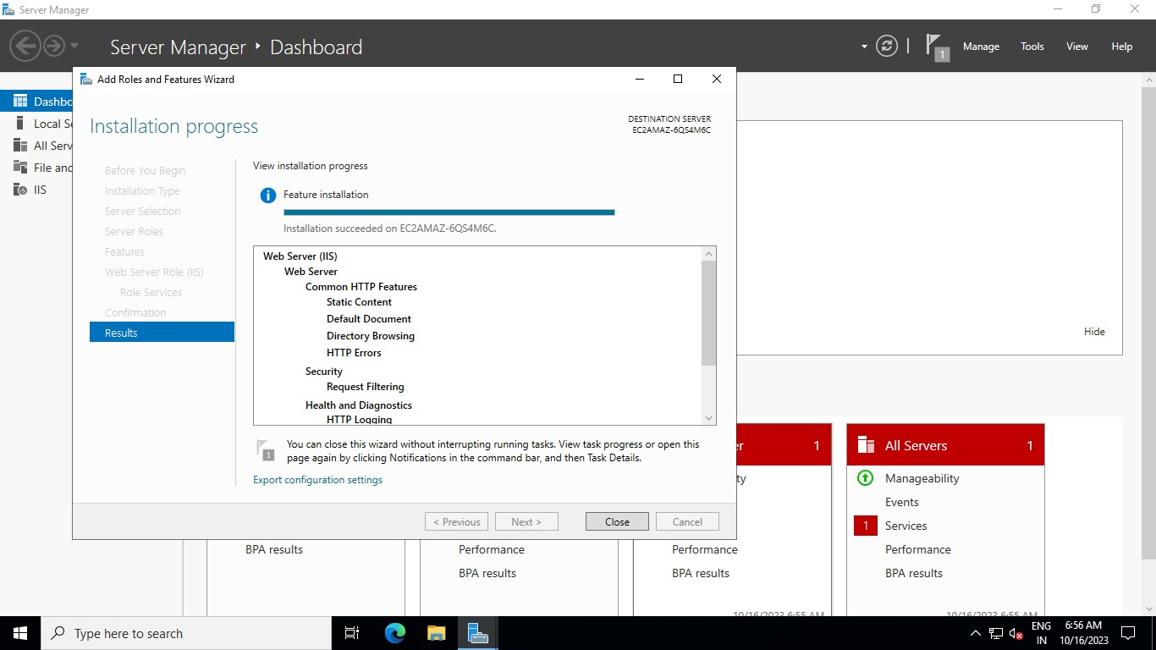

Install the webserver IIS

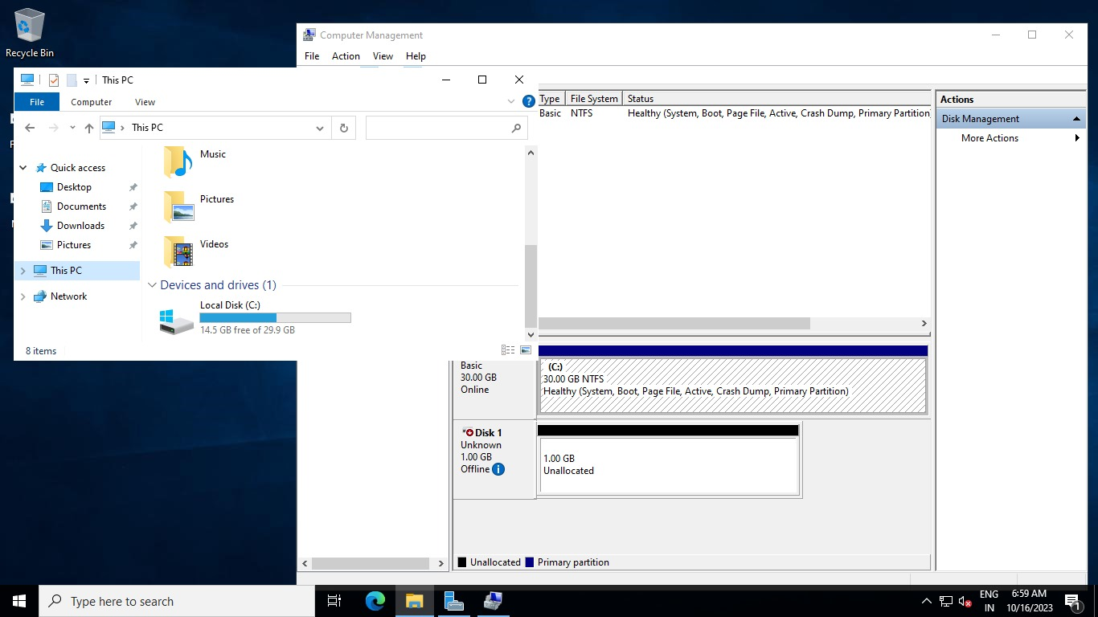

As first we have created 1 additional volume to our windows server 1A make that server online as we have seen the process in the (volume part).

Now add this additional volume (1GB)

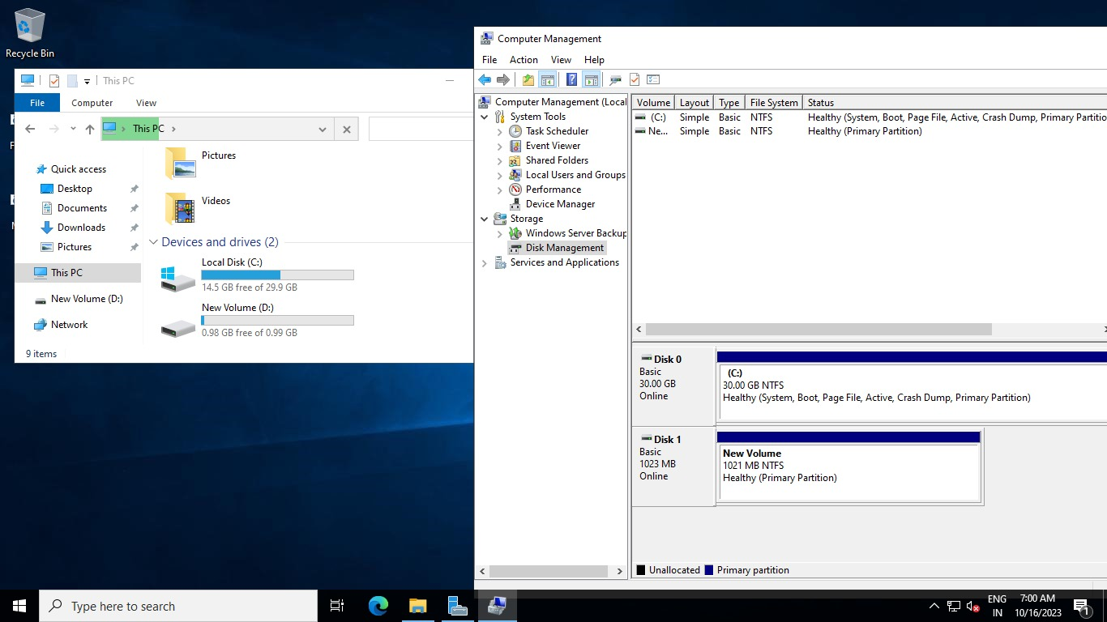

New volume added

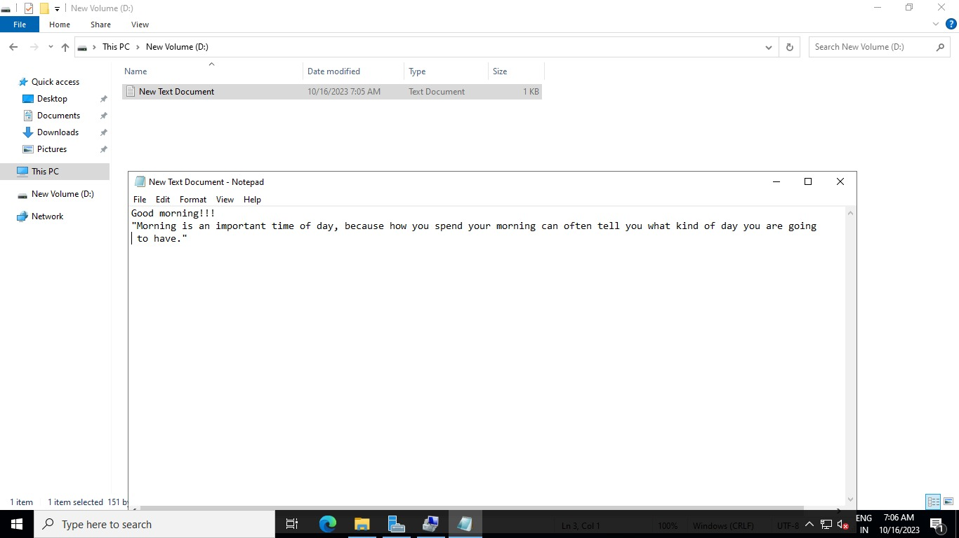

Create a new file in newly created volume (volume D)

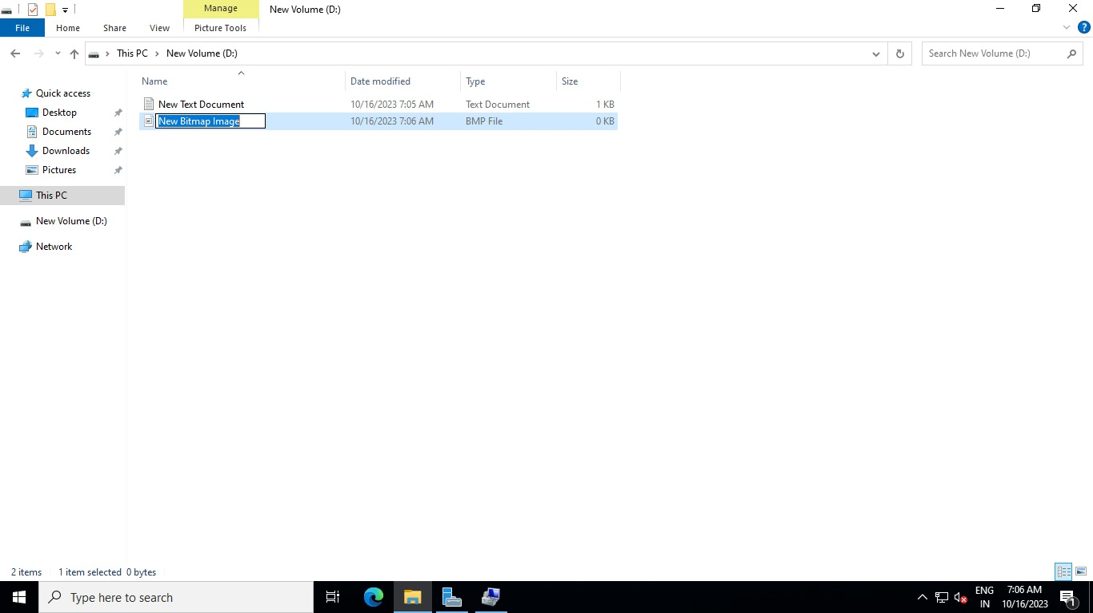

* As we have 2 files in new volume (volume D)
* Now connect to windows server-1B through RDP.

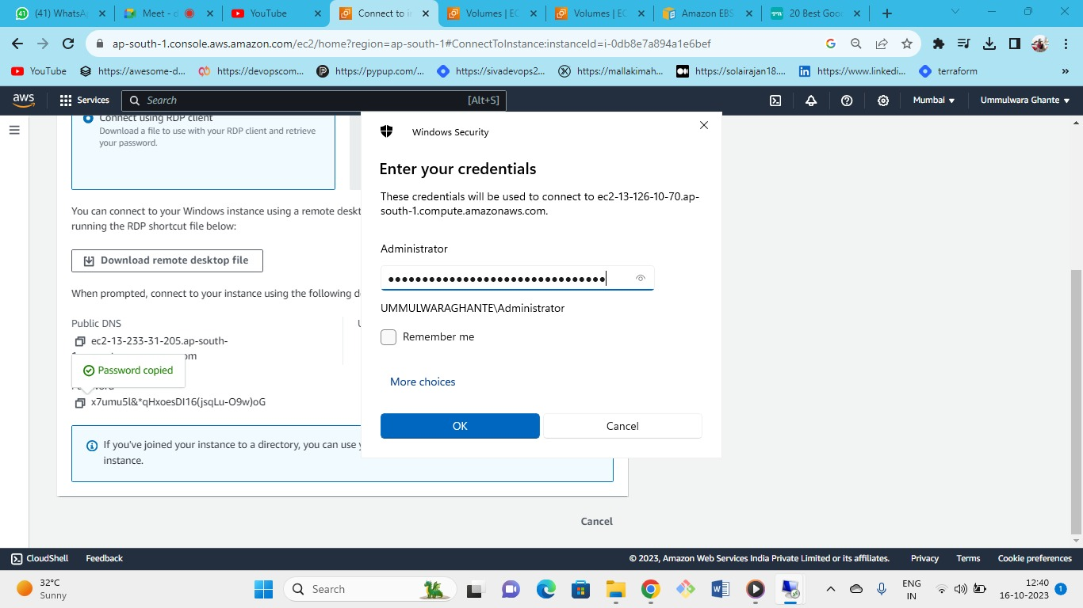



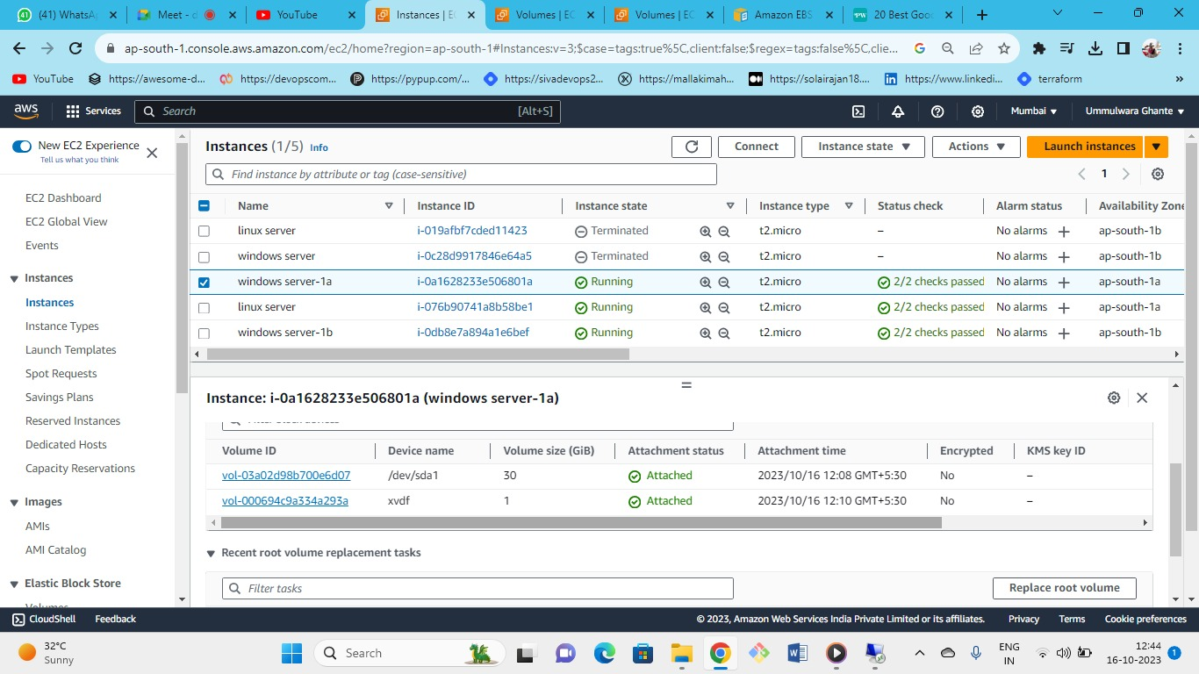

* As we have 2 servers of windows in different AZ
* Now we need to attach additional windows.v volume in windows server-1b as it is already attached to Windows server-1a.

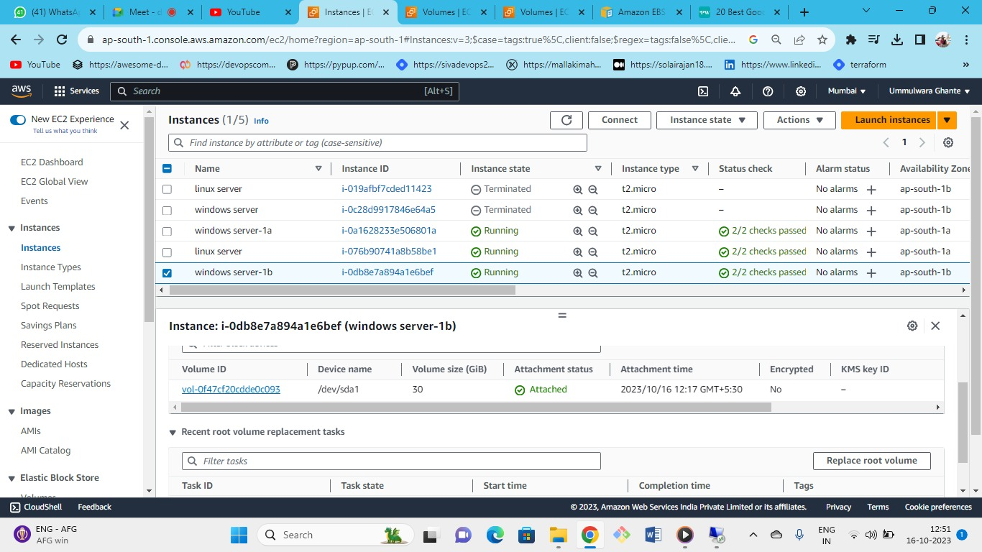

As you can see, we need to attach that additional (volume) windows.v to windows server-1b

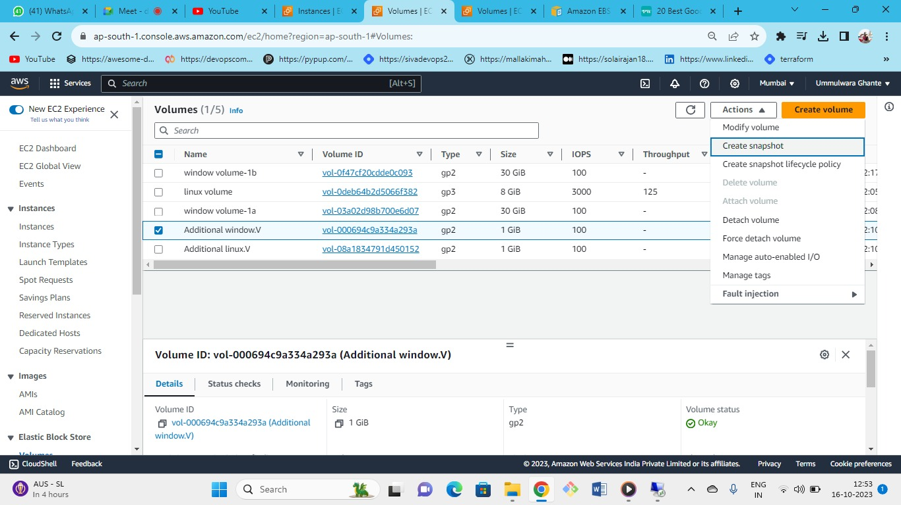

Now take a snapshot of the (additional windows.v)

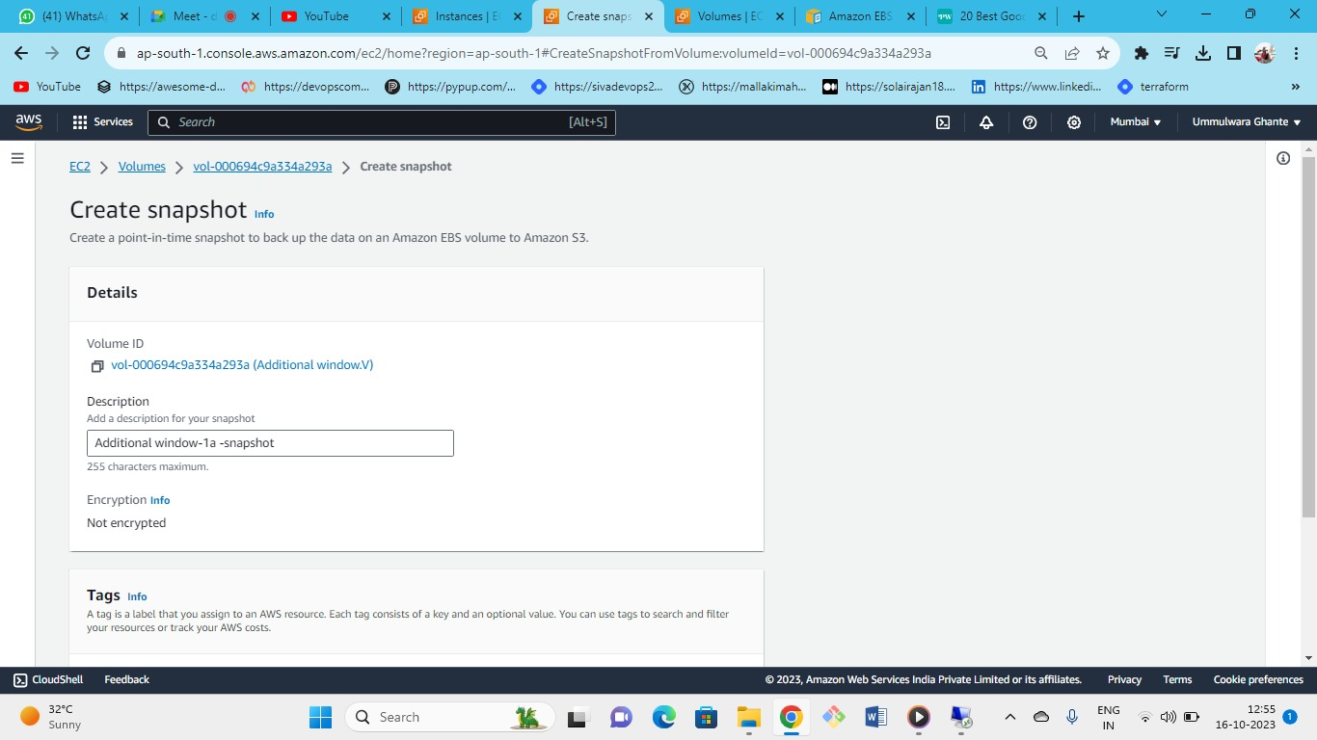

We are taking snapshot of AZ-1A instance (additional volume)

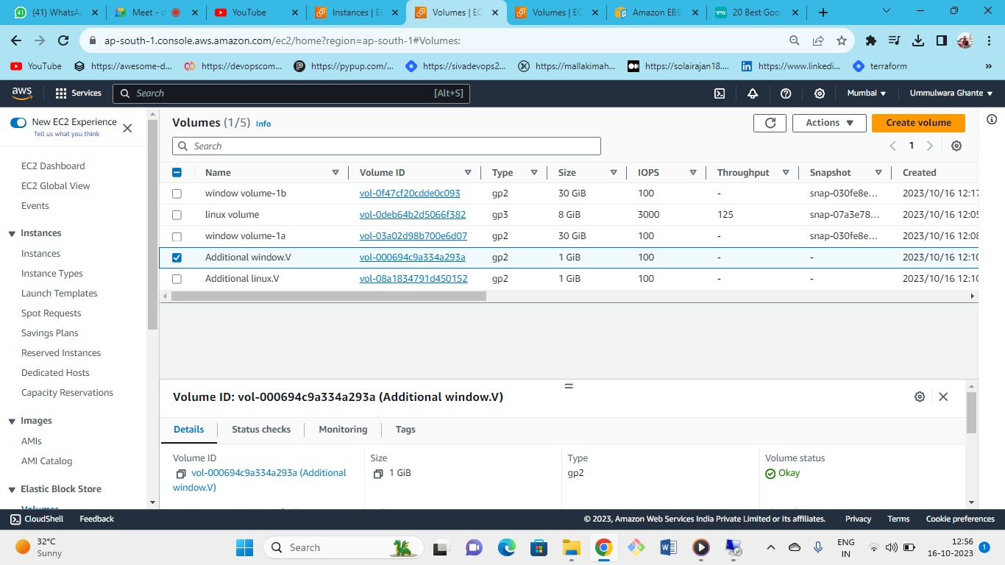

we have taken the snapshot of this additional volume.

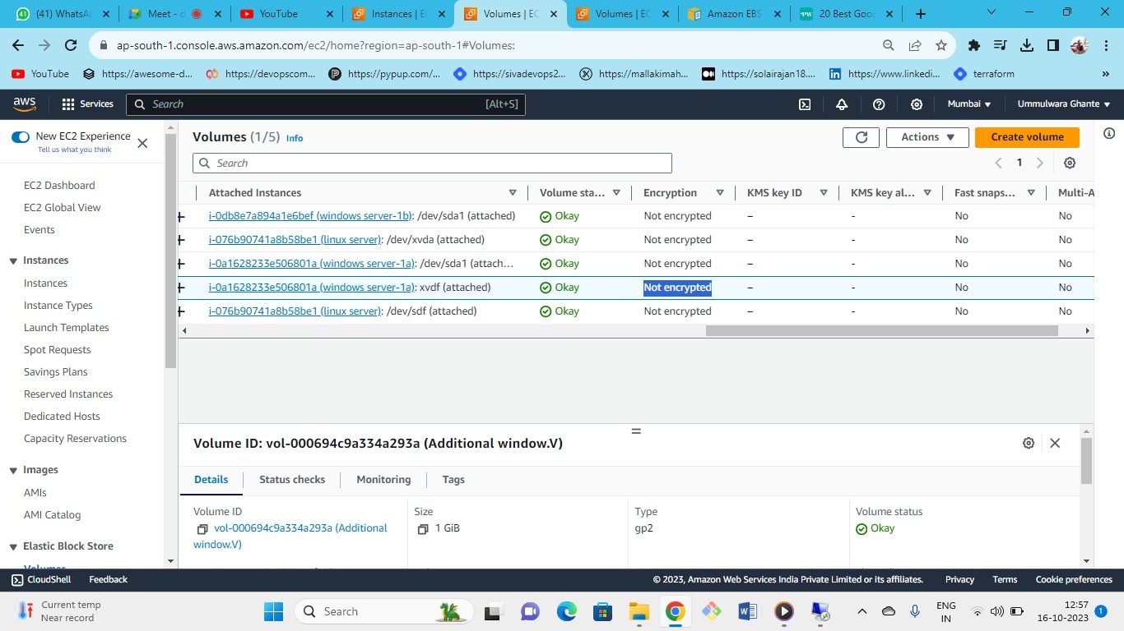

As the volume is un-encrypted then the snapshot is also un-encrypted.

By default, volume is set to unencrypted by AWS.

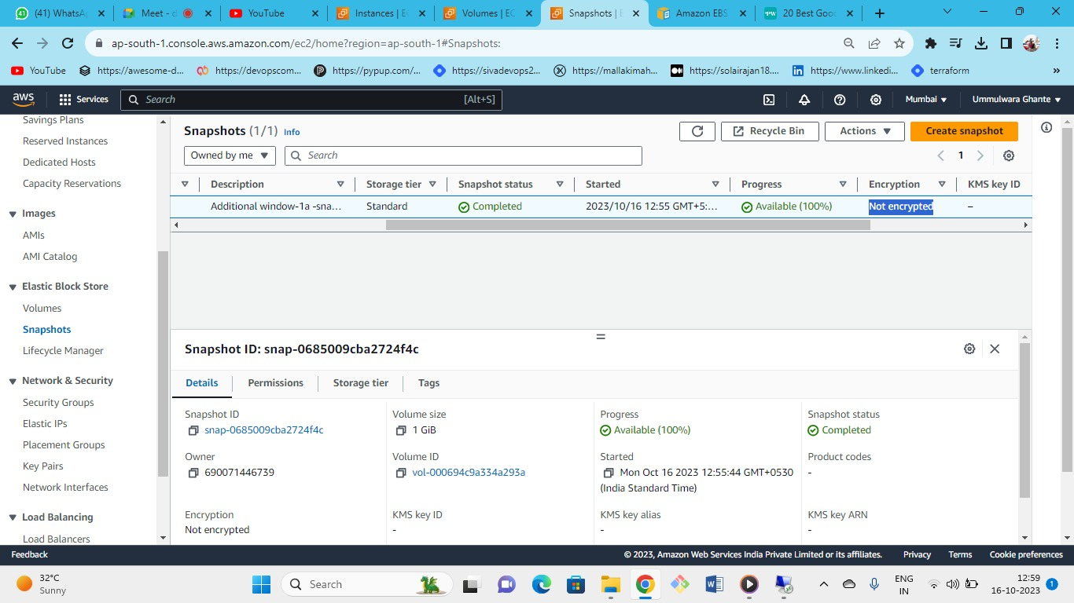

As you can see snapshot is also unencrypted.

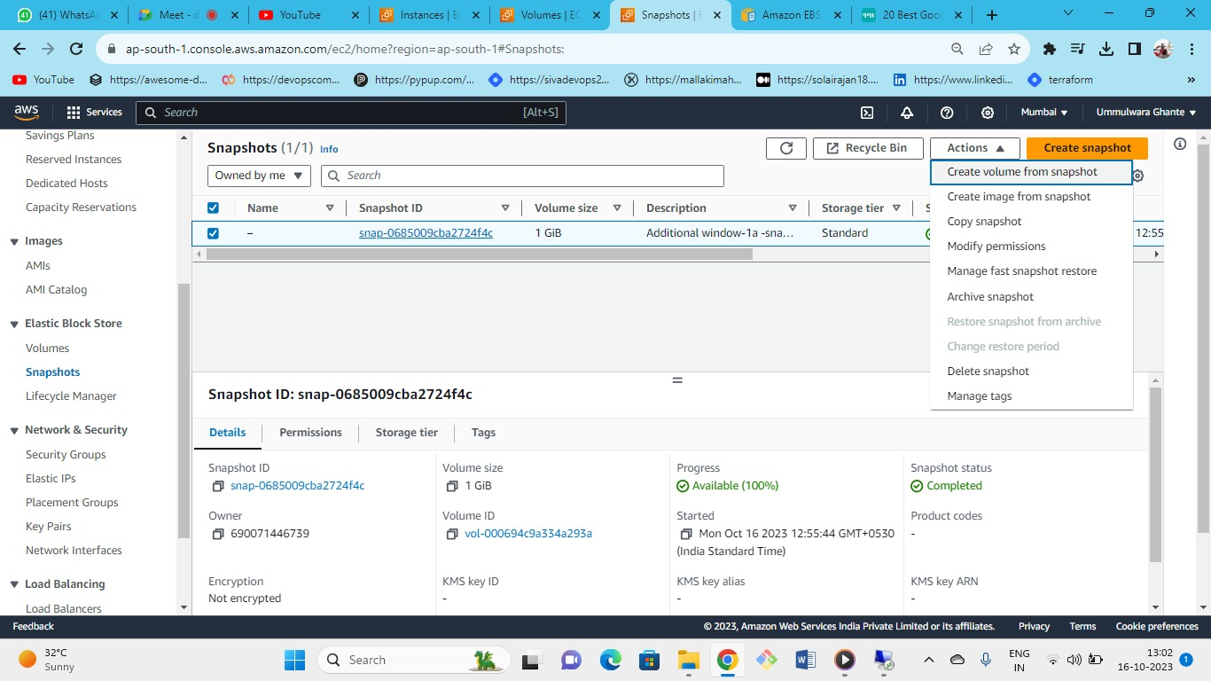

* Now we have created snapshot now we need to create a volume from that snapshot so that we can attach the volume to the instance from different AZ
* **1A instance 🡪 volume (1A)🡪snapshot 🡪volume (1B)🡪1B instance.**

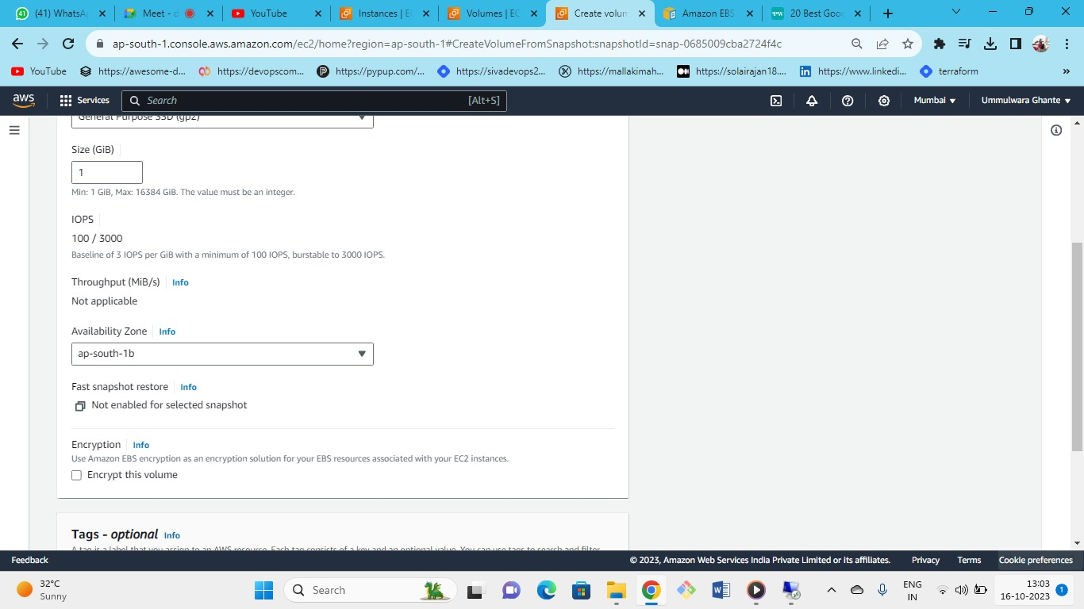

Now create a volume : Select AZ-1B for volume because we have to attach to instance in AZ-1B

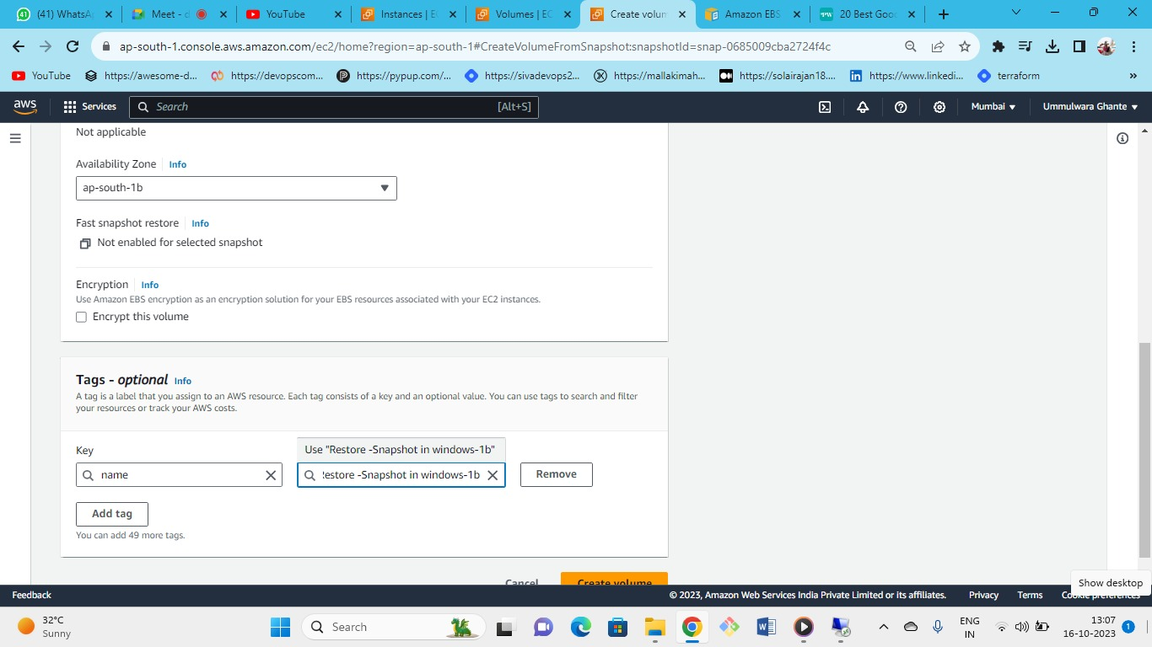

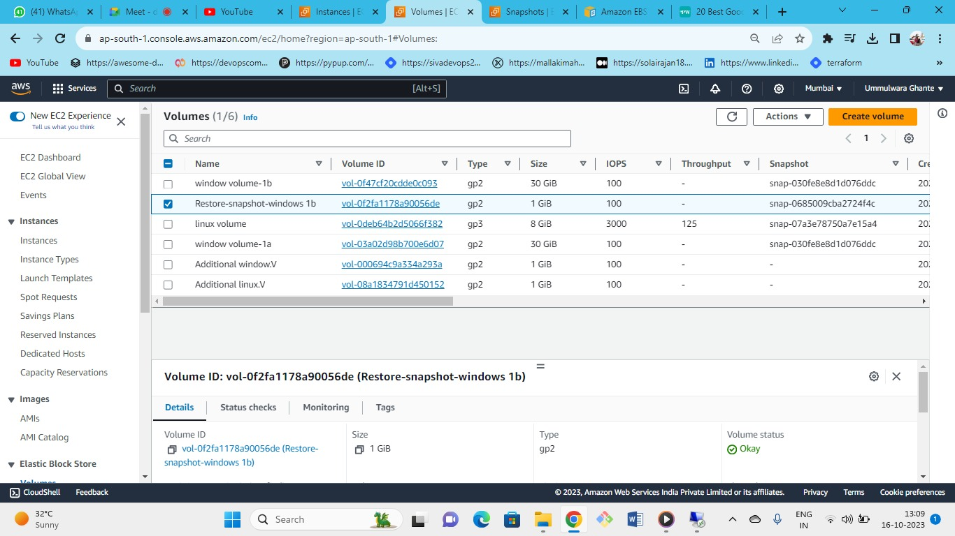

Volume created successfully – Restore-snapshot-windows-1B

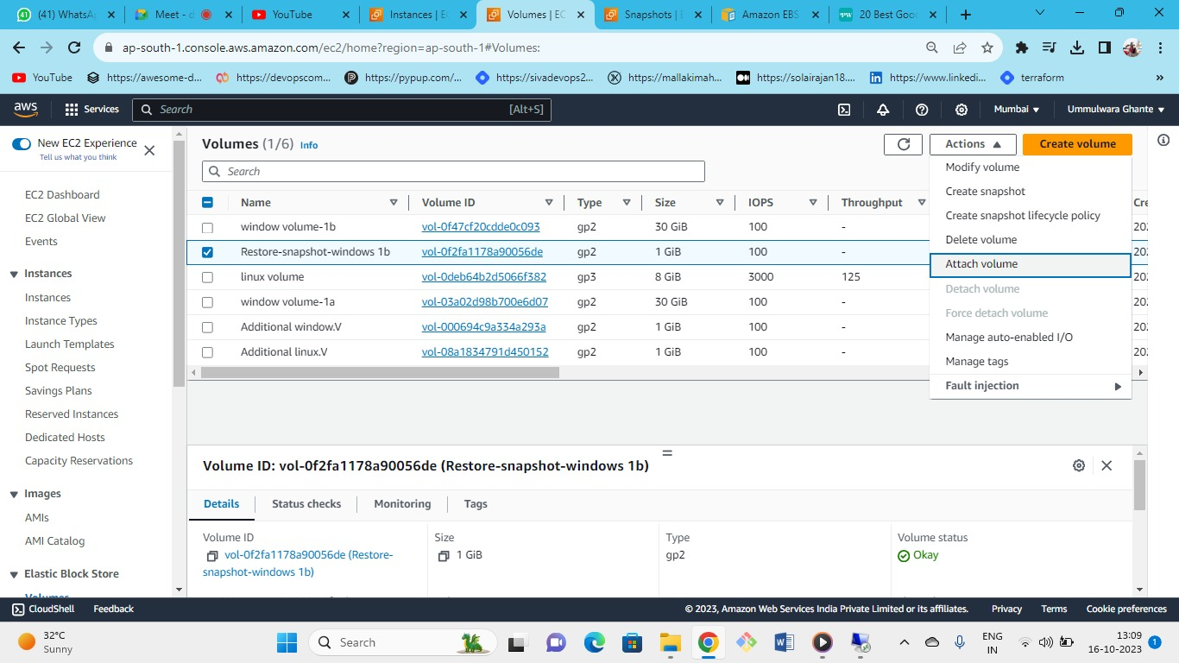

Now attach this volume to 1B instance

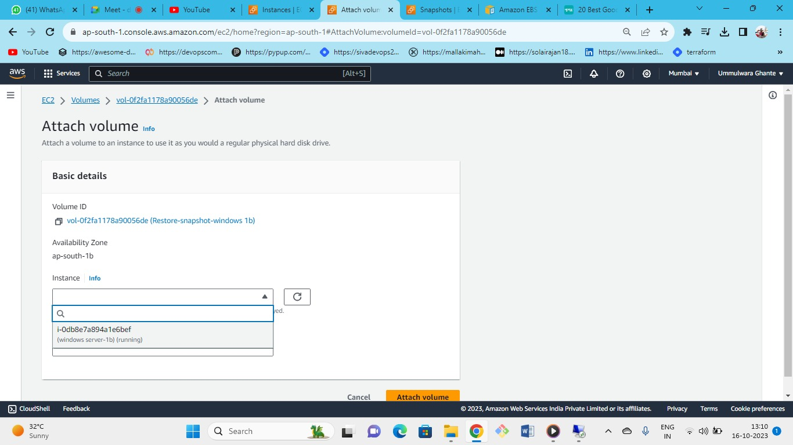

* As volume is AZ specific (1 Volume 🡪 1 AZ)
* E.g., If you create and instance in AZ-1A and create a volume in AZ-1B then that volume will not get attached with that instance as volume is AZ specific.
* And the process we are doing is region specific (Will not Work).
* 1A instance 🡪 1A volume (will get attached)

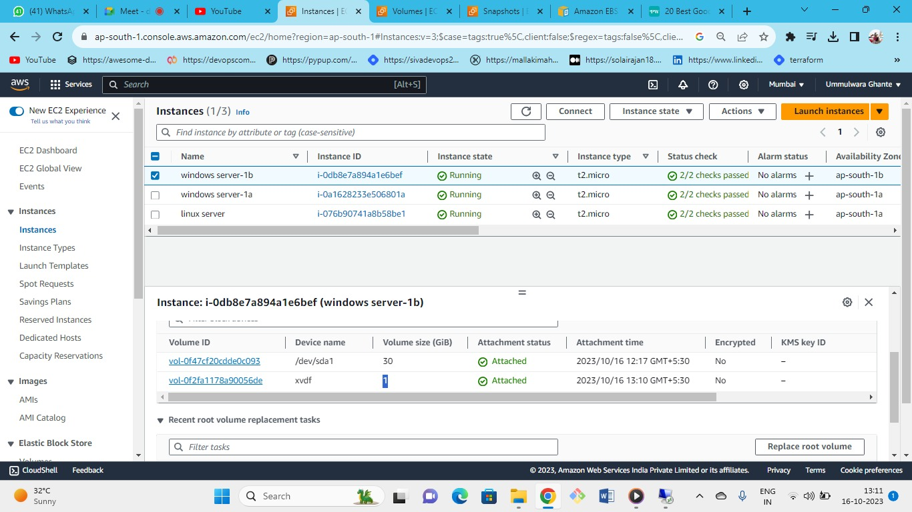

* Now connect windows server 1B to RDP
* As you are in windows server-1B here you need to just make the volume(the volume which is crated from the additional snapshot for windows server 1B) online.

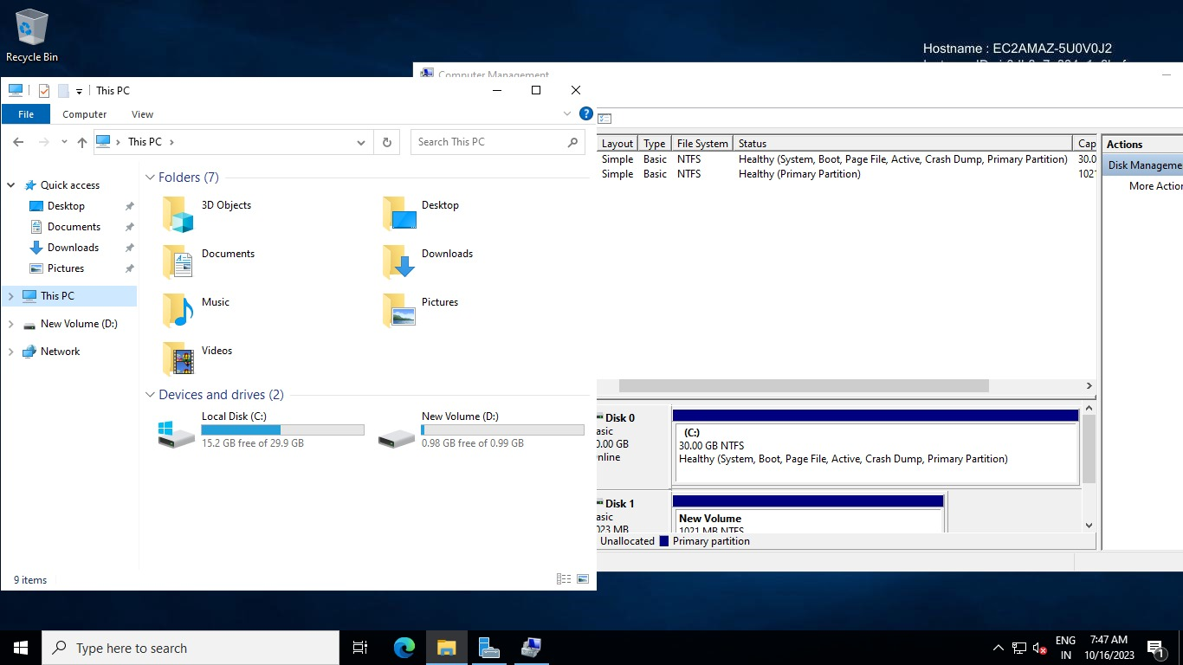

As snapshot keep all the data and regarding things same you just need to make volume online

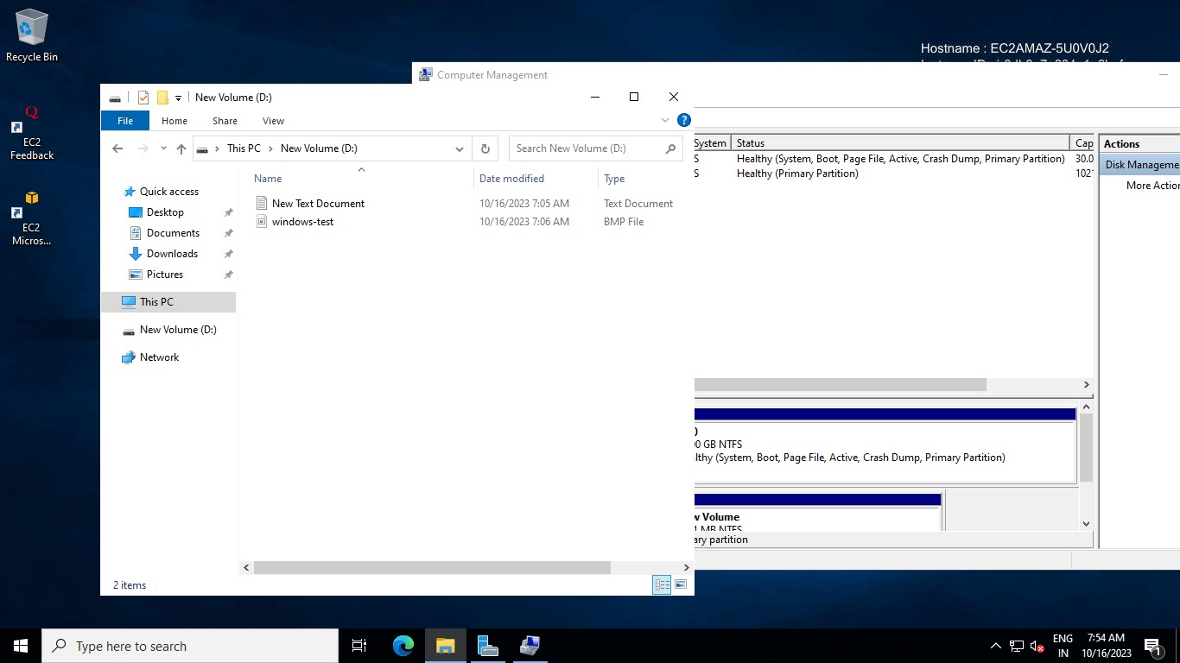

All the folder and things inside are same.

1. **Different region but Same AZ – (volume 1 in Mumbai -1A)**🡪 **want same volume in (volume 1 in N Virginia 1A).**

**CASE 2**

Across the regions

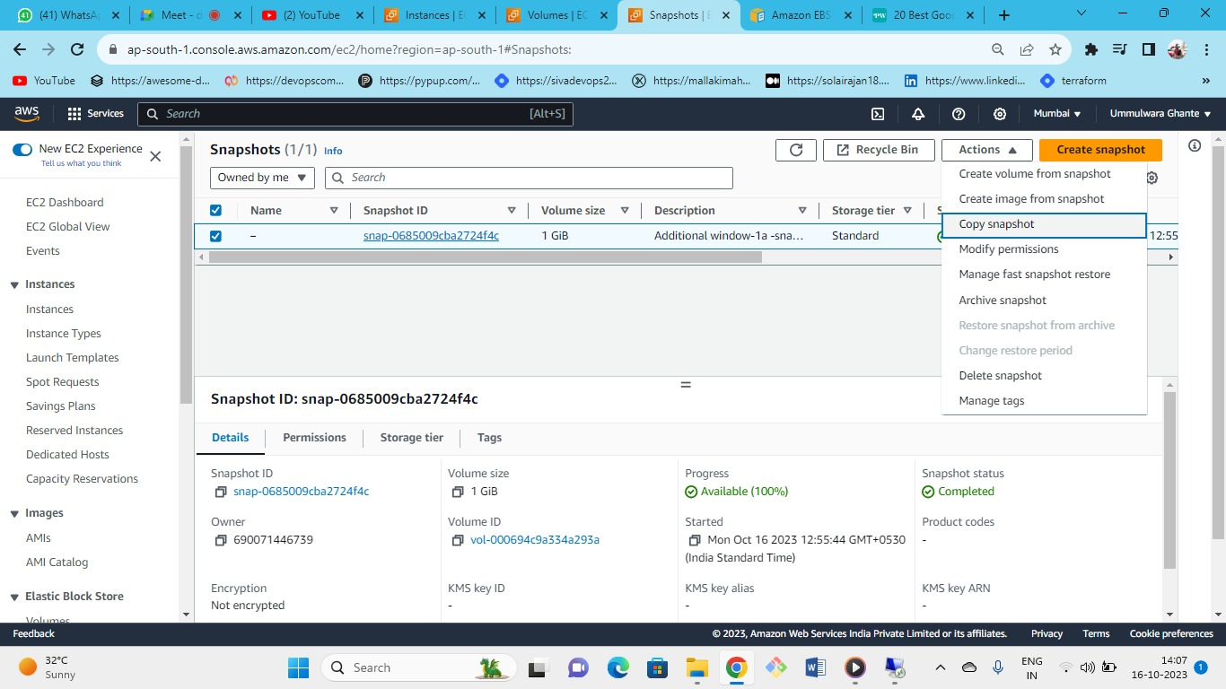

* If you want to copy volume in different region but same AZ-1A then
* Snapshot 🡪 Copy Snapshot to another region (e.g. N-Virginia) 🡪 In N-Virginia create a volume from that snapshot in same AZ-1A.

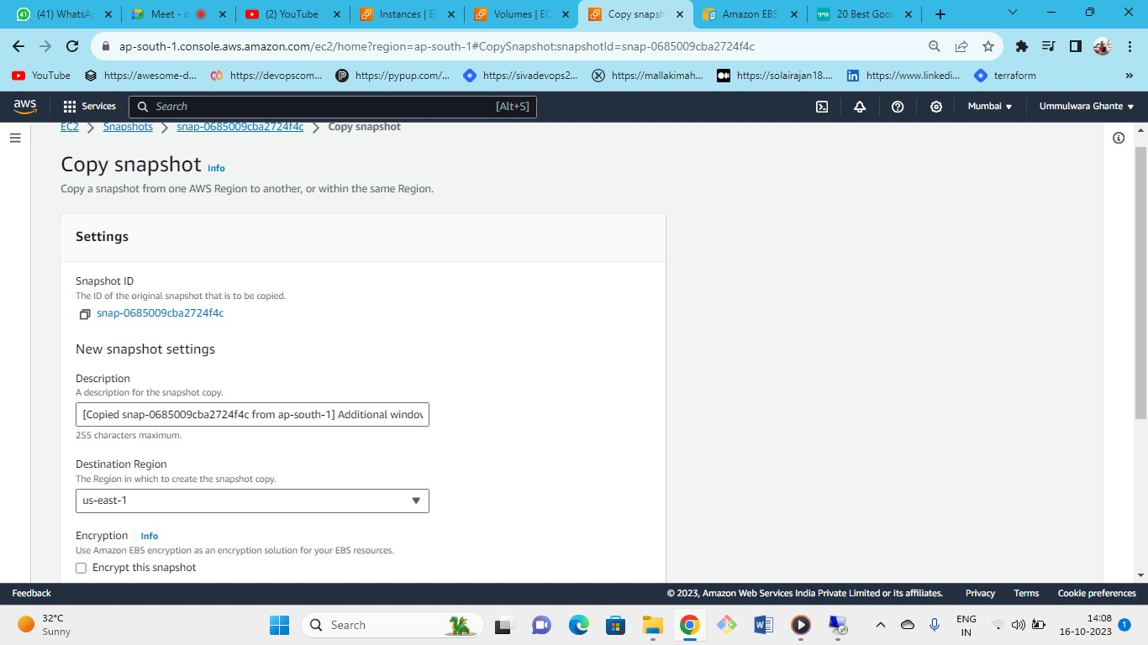

Write the destination where you need to copy the snapshot and even you can encrypt the snapshot so that created volume will also be encrypted.

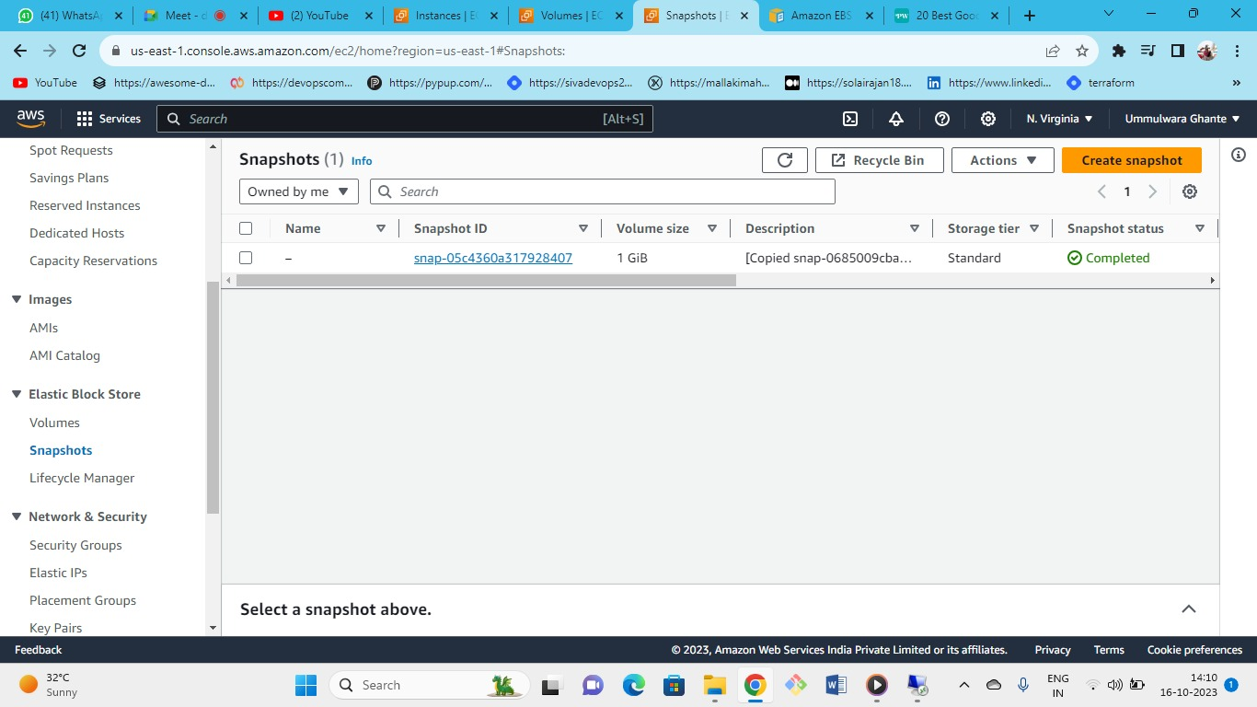



In Virginia we have successfully copy the snapshot

Now you can create a volume from this snapshot.

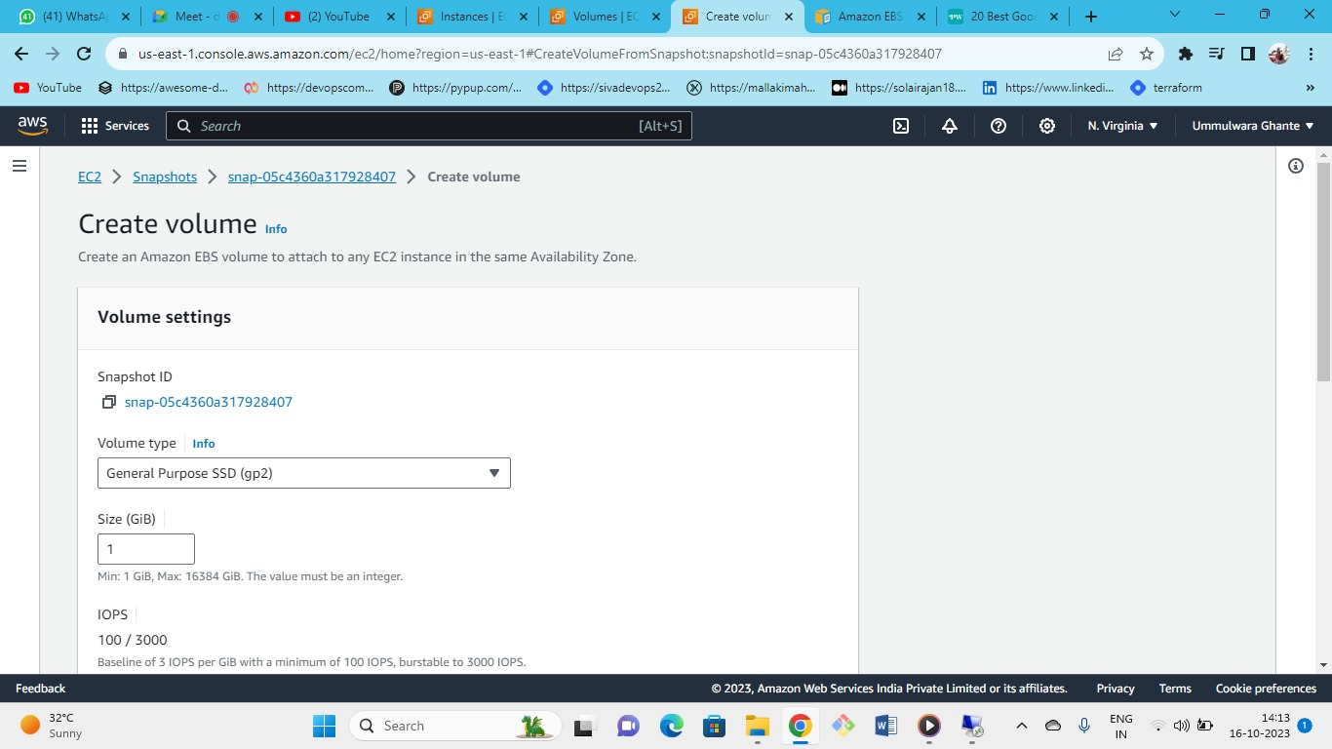



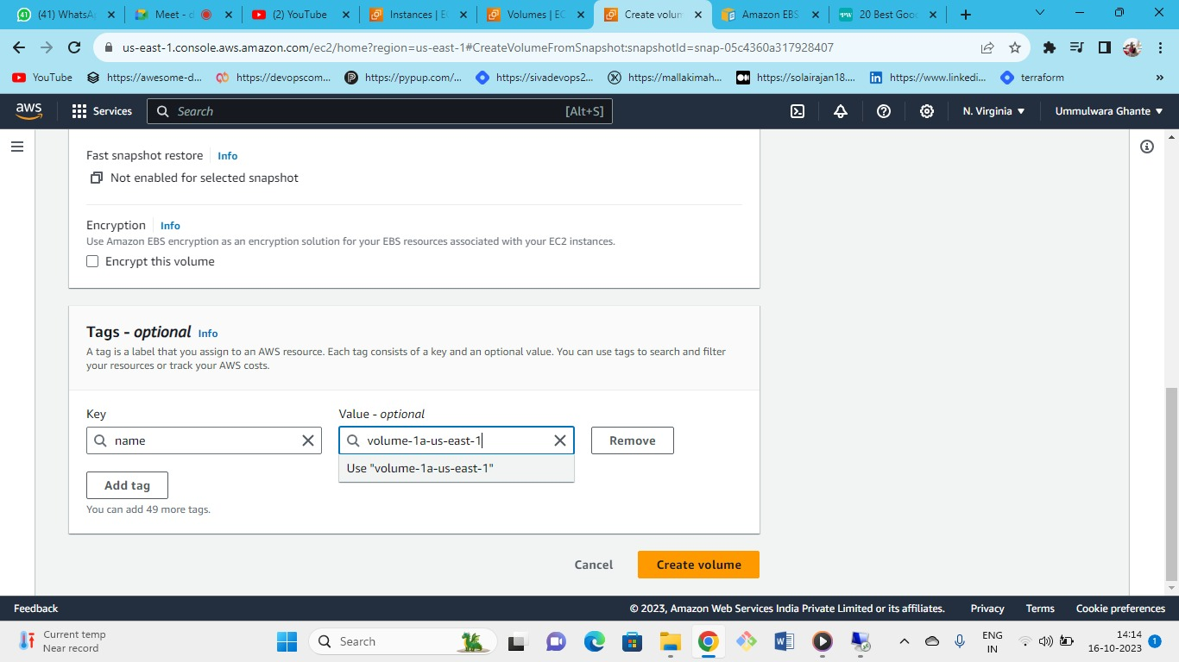



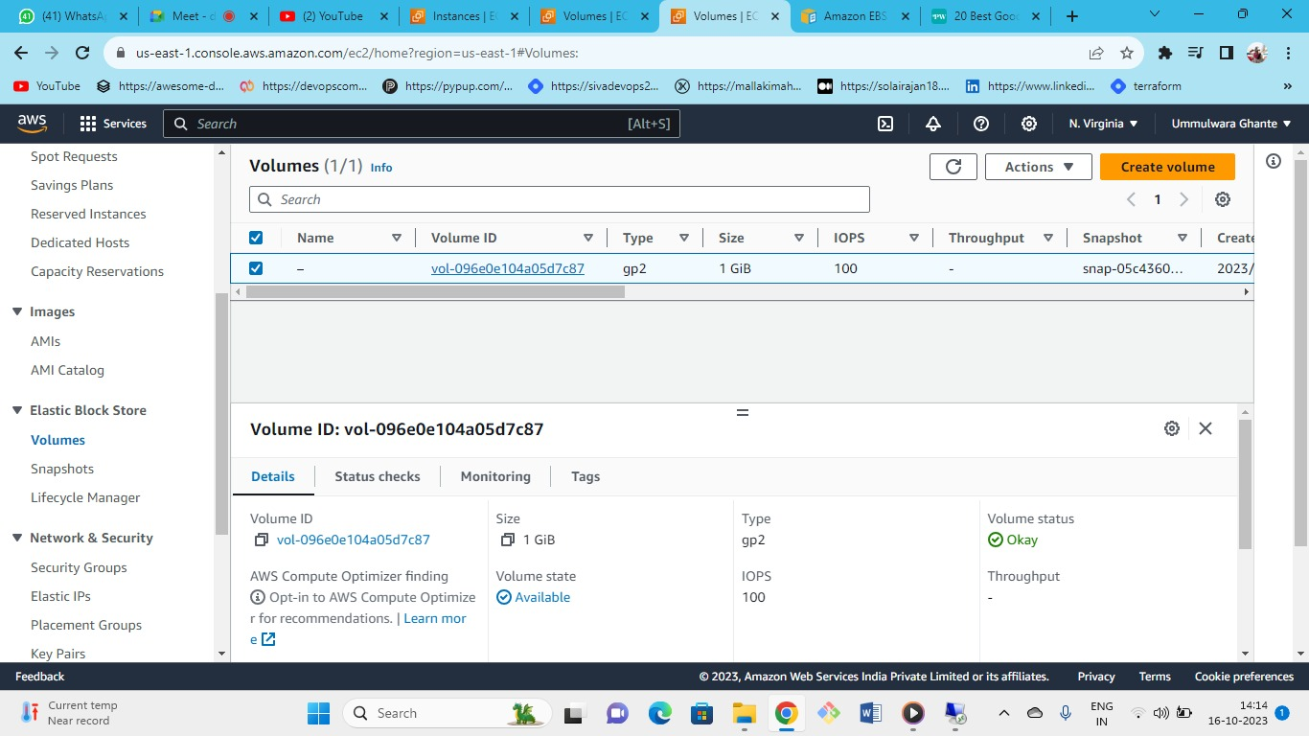



* Created volume in N-Virginia
* **Volume Mumbai-1A---> create snapshot (Mumbai-1A)--> copy snapshot to the region we want-->finally you can create volume from this snapshot at that region (e.g., N Virginia).**
* Cross region.
* As you can see volume in that the same data will be present in the N-Virginia (in the above image you can see the volume which we have created in the Mumbai region using snapshot).

Snapshot case1:

Added new file in (additional windows.v)🡪

Went in Snapshot and created volume-🡪

Attached volume to windows server 1b.

Let’s start:

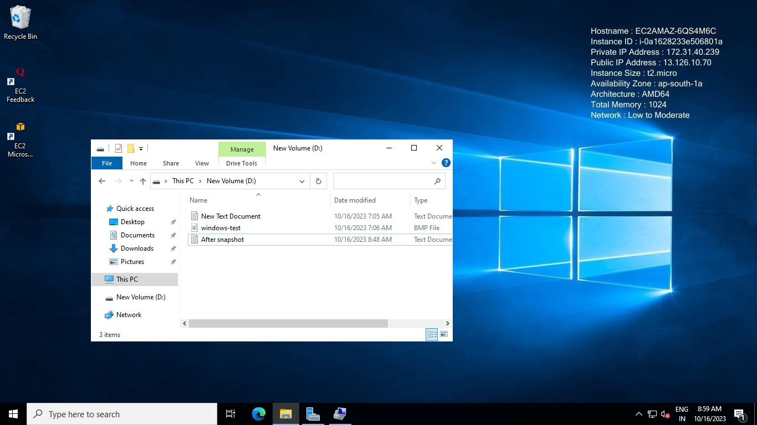

* Get back to the original volume (additional windows.v) (Mumbai) from where we have created a snapshot that is windows server 1a and create a document file (after snapshot).

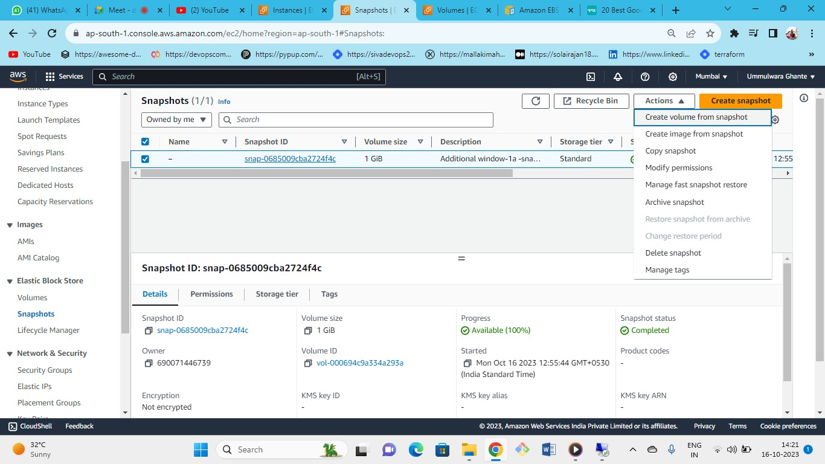

* Now you are in Mumbai region (In the Mumbai region in additional windows.v we have created one file i.e. after snapshot)

**Note:**

Instead of taking snapshot of the volume- (additional windows.v) [newer volume – 3 files] we created volume of the older snapshot [i.e., which had 2 files].

* From the older snapshot we need to create a volume.

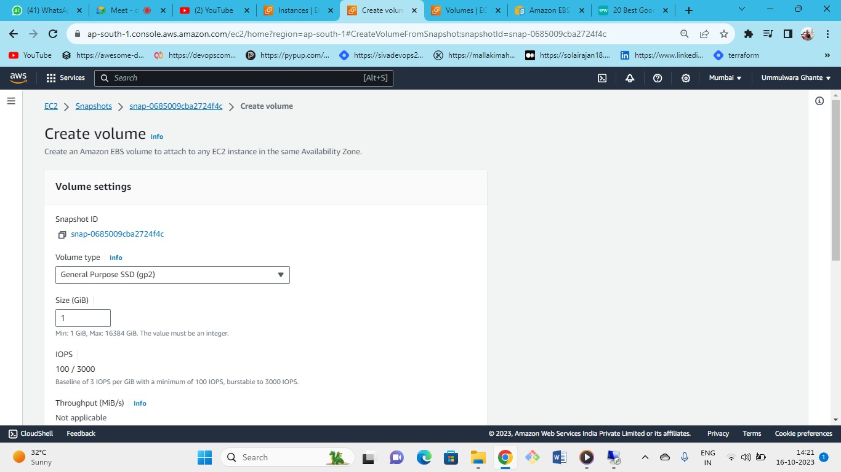

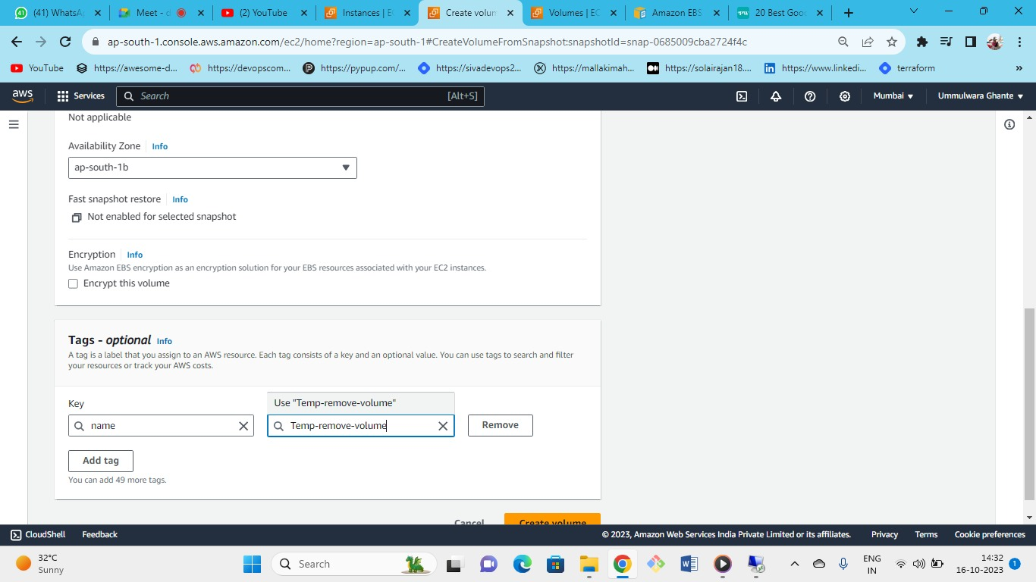

Now create new volume (in AZ 1B) named as temp from the older snapshot of the (AP-South 1A Mumbai).

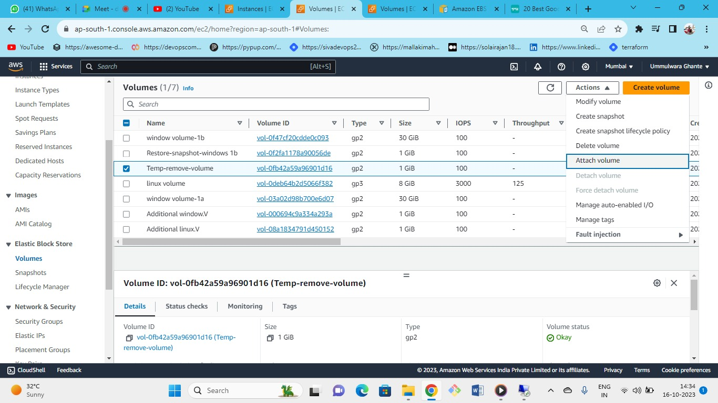



Now attach the volume to the instance 1B of AZ-1B.

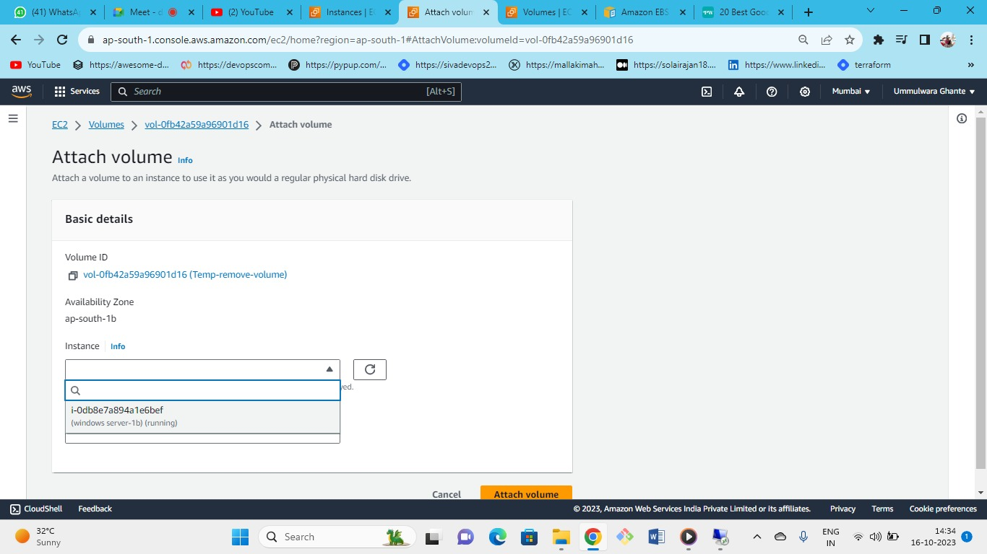

Successful attached to windows server-1B.

Now connect windows server 1b with RDP to check if the (after snapshot file) has been uploaded in the newly created temp volume.

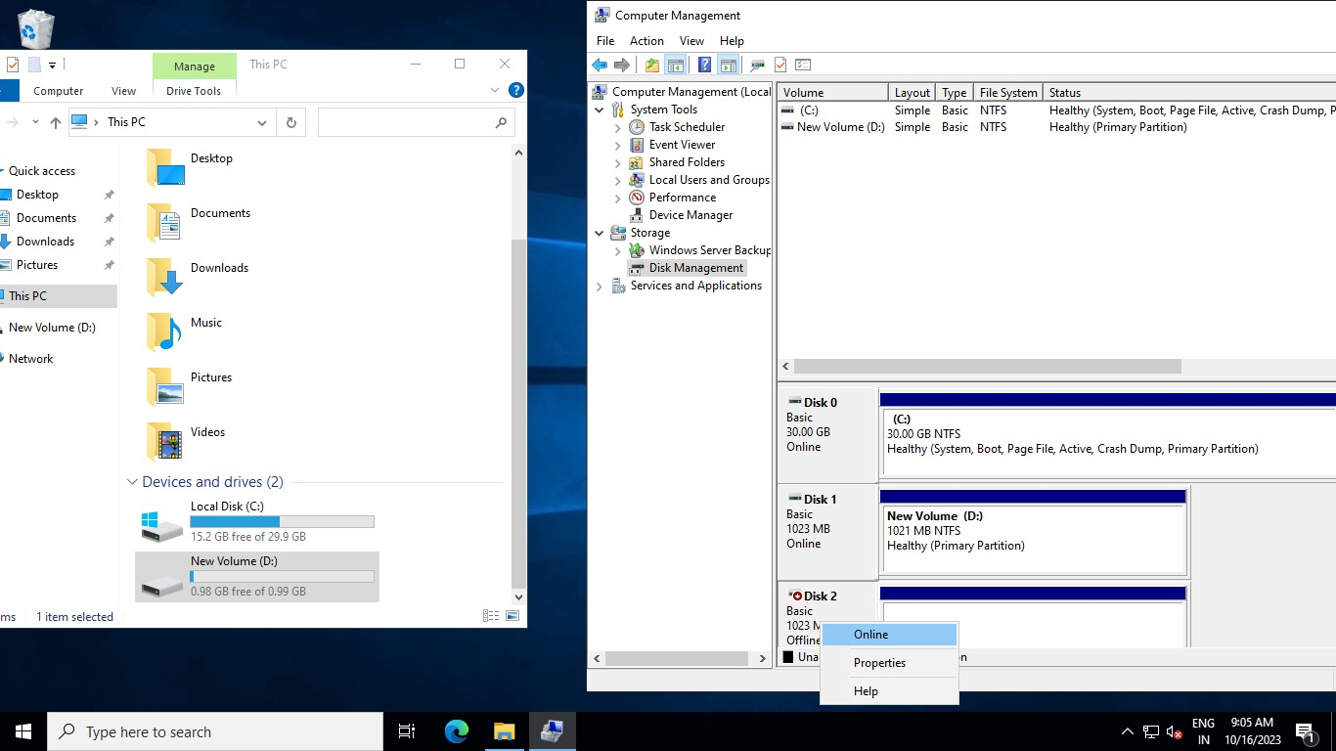

Now make this new uploaded volume online.

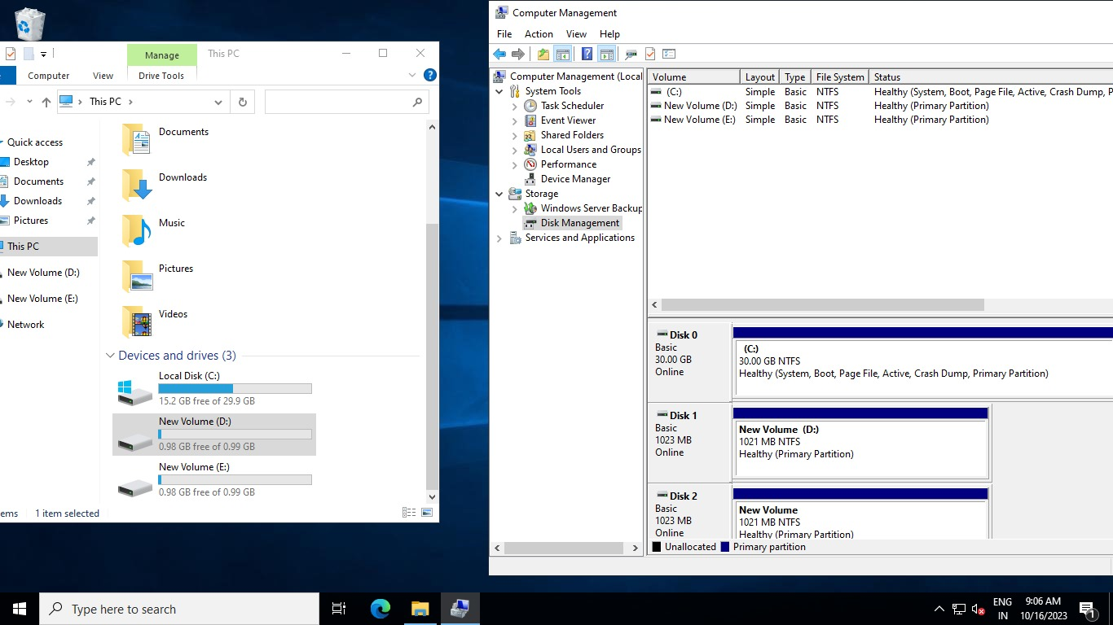

When we open (new volume D) folder we can see only 2 files the 3rd (after snapshot file)one is not available.

As data will not change in snapshot from this, we can say snapshot are **point in time** as whenever you take snapshot at that time only that data will be available.

## Snapshot Case 2

Create a snapshot of (additional windows.v)-🡪

From that snapshot create a volume-🡪

Attach that volume to windows server 1b🡪

There we can see all 3 flies.

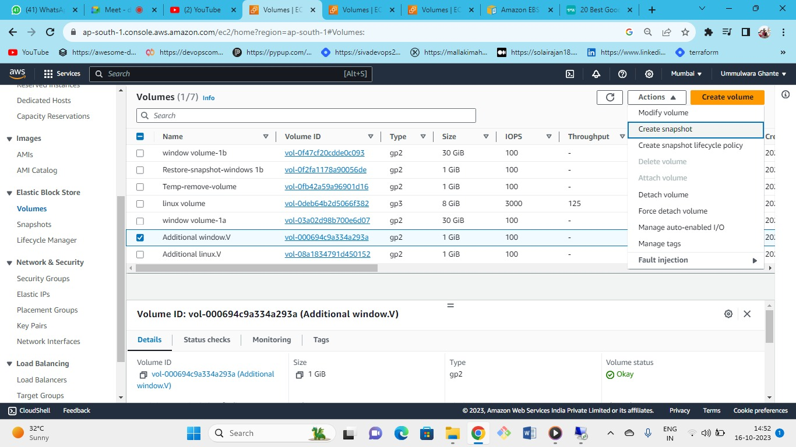

Now create one snapshot from the original volume (additional windows.v) where we have done some changes like created (after snapshot doc).

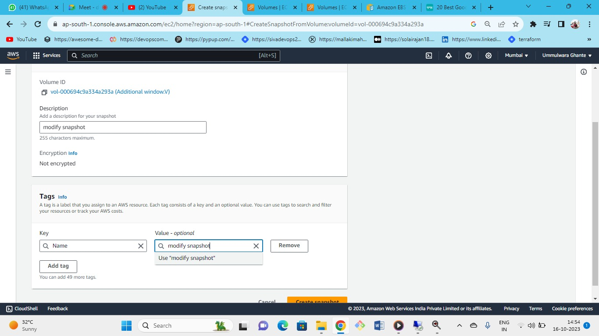

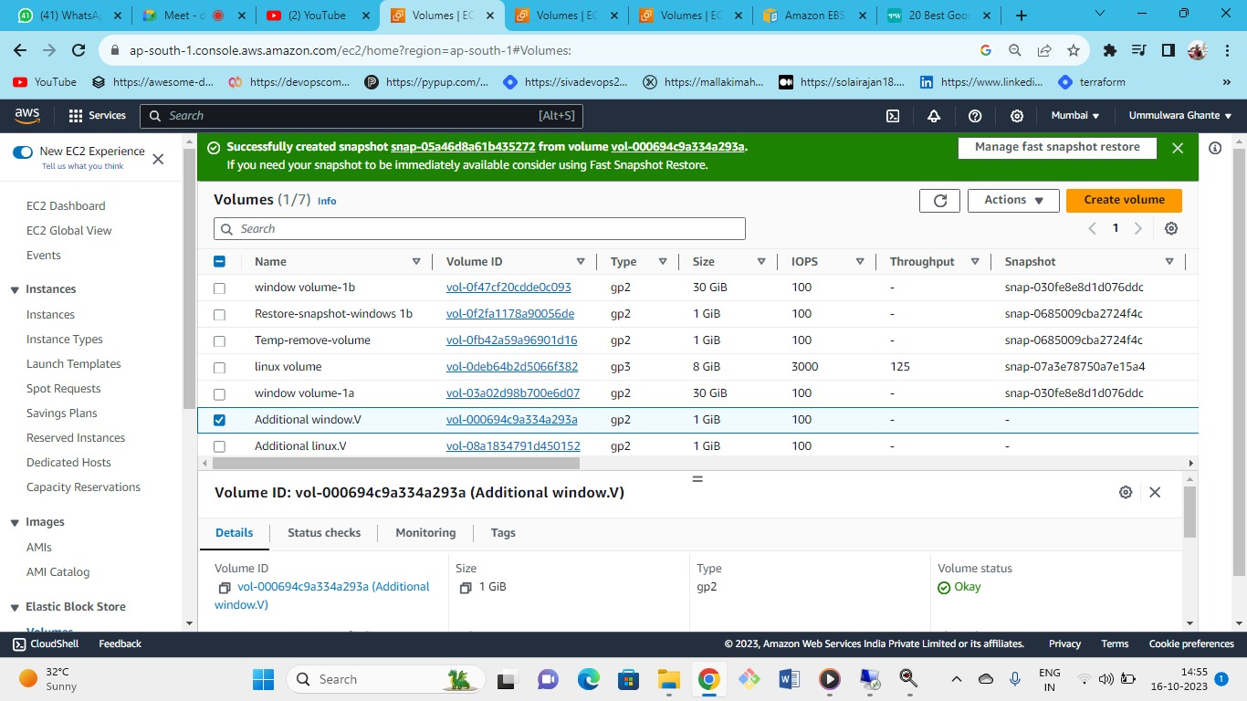

Successfully created snapshot named as modified snapshot.

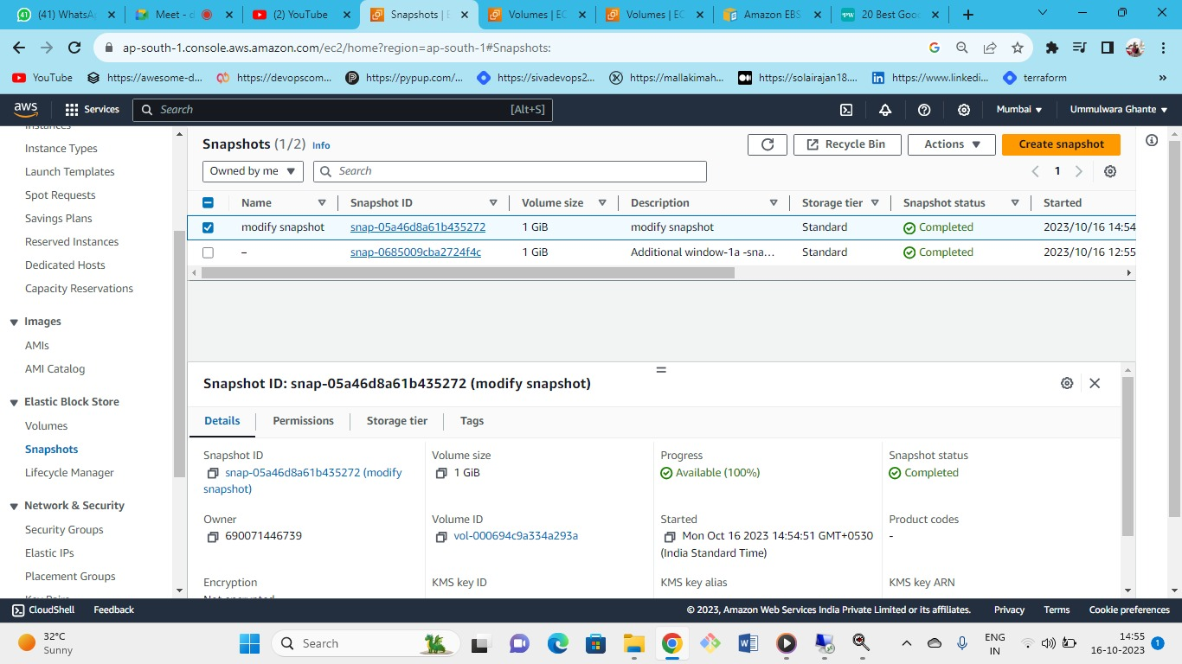

* Here the modified snapshot has been created from the additional windows.v
* Now again create a volume from this snapshot in az-1b (for windows server 1b)

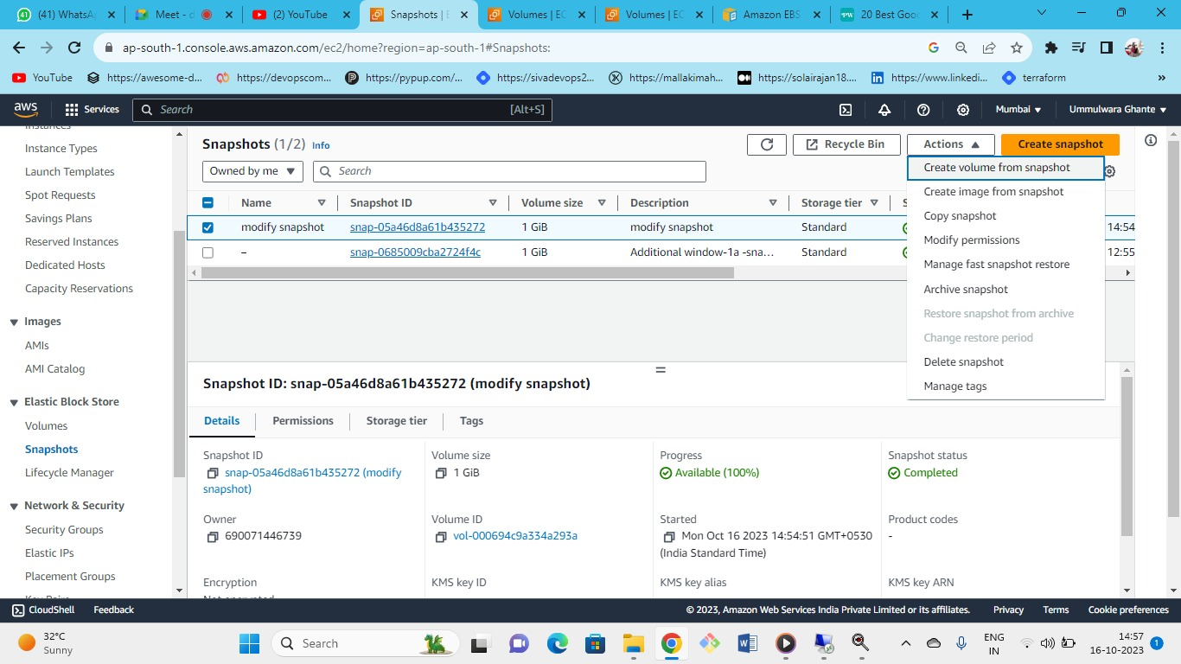

Create volume from modified snapshot

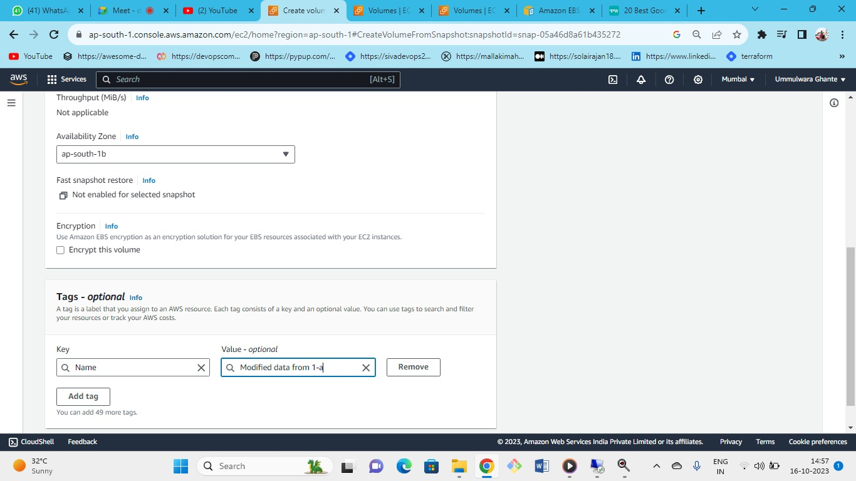

Created volume in AZ-1B.

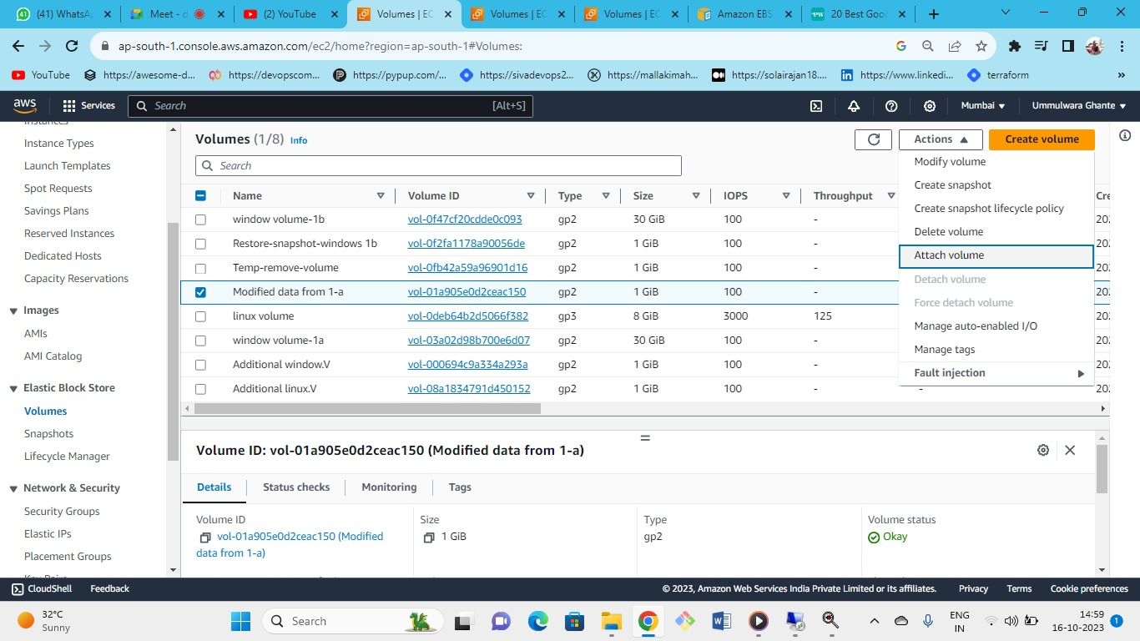

Attach volume to (windows server 1b)

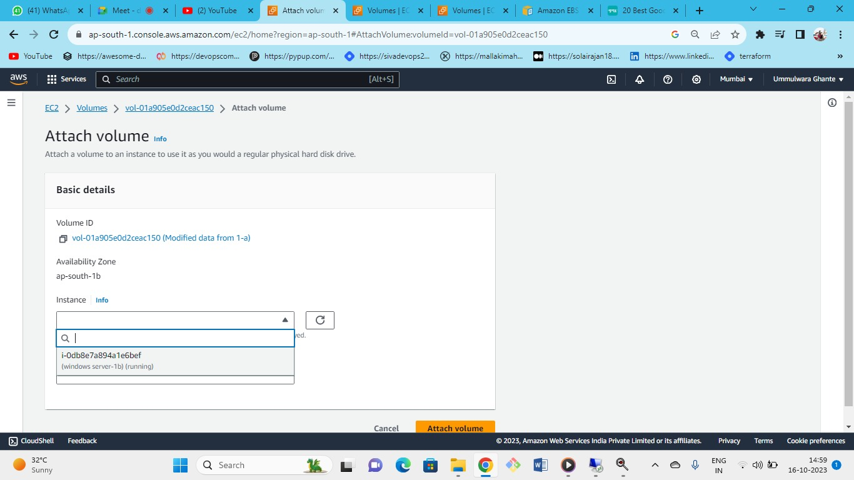

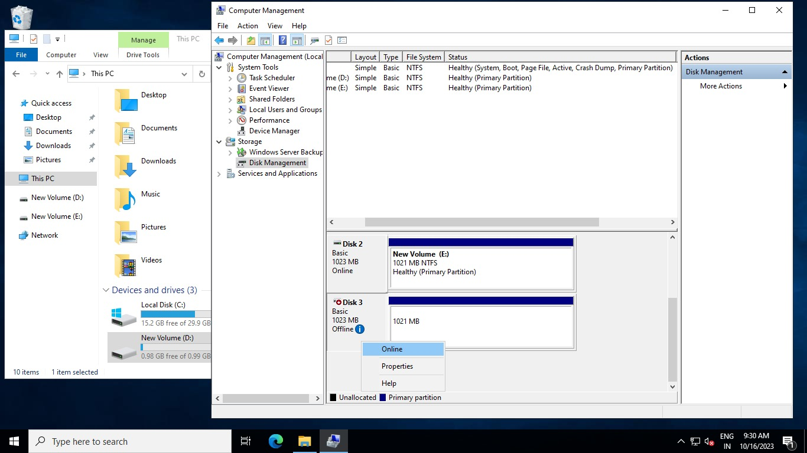

As we can see the new volume that we have attached

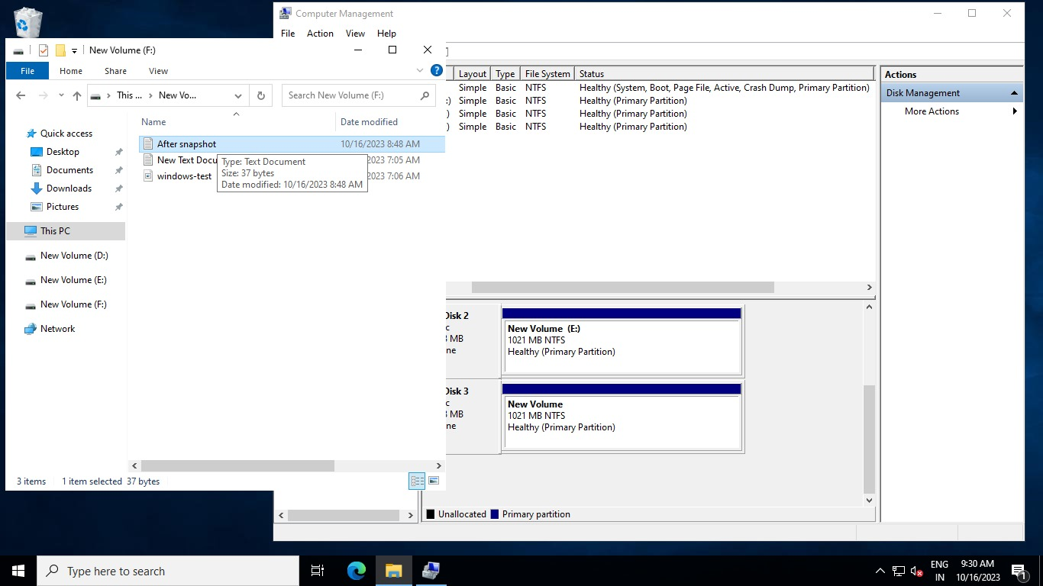

As we can see the file (after snapshot) in this volume has been successfully created

This is because we took snapshot of the additional windows.v volume where we modified our data and from that we created a latest modified volume in (1B) to attach to (windows server 1b).